The Lloyd Williamson School Nurseries

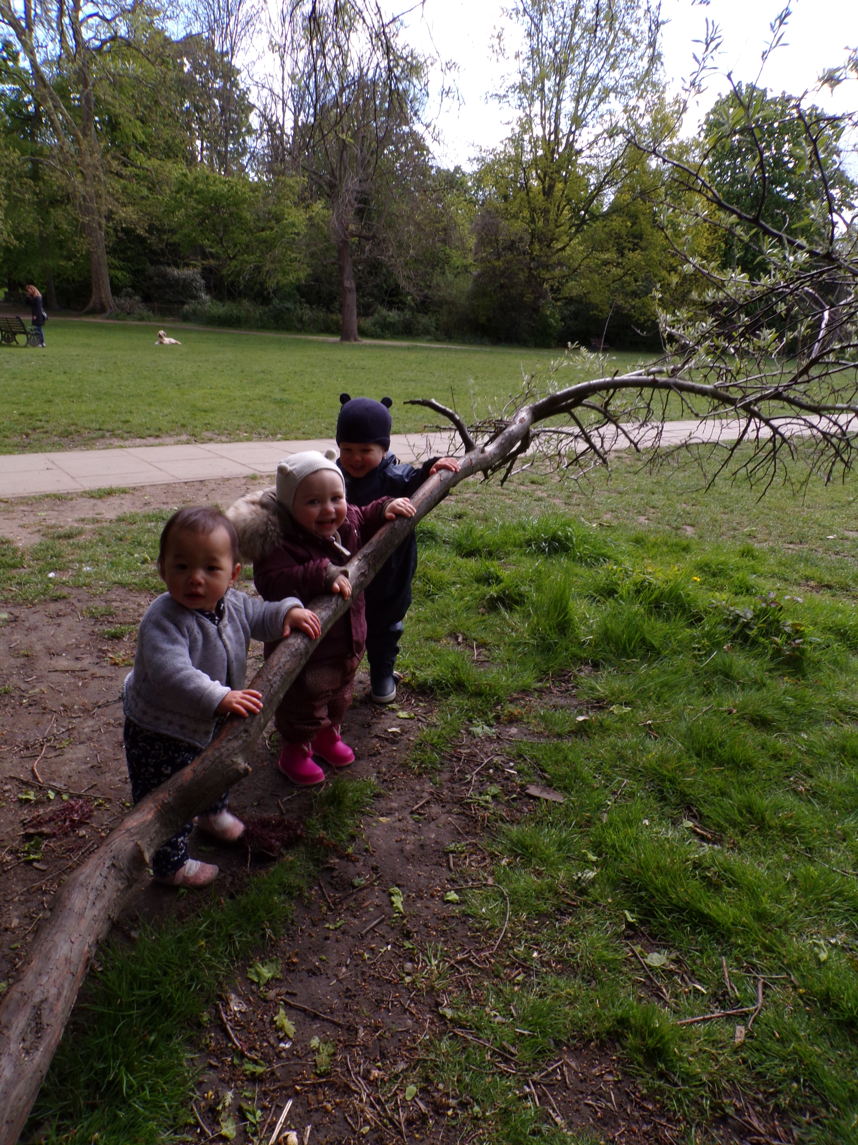

Curriculum Statement
2021-2022

Intent
At The Lloyd Williamson Nurseries we believe that all children deserve an education that is not only stimulating and engaging in context, but which also allows children's natural creativity and curiosity to flourish whilst working towards their learning goals. We believe that by creating a fun and nurturing environment that it gives children the best chance to become well-rounded, happy individuals, ready to succeed in an ever-changing world.
At the Lloyd Williamson Nurseries we recognise the importance of giving our children the best possible start to their early years education by creating secure bonds and having well planned activities and implementing teaching and learning opportunities that supports them in reaching their full potential. We know that our children join our nursery with varied life experiences, and we aim to plan teaching and learning opportunities accordingly to address this whilst creating a Home from Home during their stay with us.

We use the new EYFS 2021 framework (Early Years Foundation Stage) as well as the Development Matters Non-statutory curriculum guidance for the early years’ foundation stage. We recognise at our nurseries the crucial role that Early Year’s education plays in providing firm foundations upon which the rest of a child’s education is successfully based.
Therefore, it is our intention to provide an enriched, well rounded and stimulating learning environment where children can work in partnership with adults and peers in a environment of mutual respect to develop;
- Confidence in themselves and their ability to learn.
- The social skills necessary to learn.
- The emotional capabilities to enable them to understand their feelings and to solve problems.
- A unique child.

We aim to provide children with a ‘Home from Home’ this means having the same, safe, secure, nurturing environment that they would at home whilst also creating a well-structured, active learning environment both indoors and outdoors. This will enable children to develop the skills, attitudes and understanding which will help to form the basis of lifelong learning and encourage children to become active members of a diverse and constantly changing society.

Implementation
At The Lloyd Williamson Nurseries we meet the welfare requirements laid down in the Statutory Framework for the Early Years Foundation Stage. We actively safeguard and promote the welfare of all our children and take this as our highest priority.

We acknowledge and recognise that children will learn most effectively when they are healthy, safe and secure, when their individual needs are being met and when they have formed positive relationships with the staff who care for them and their peers.

We aim to provide a setting that encompasses a safe and stimulating environment where children are able to enjoy learning and grow in confidence so they can achieve their full potential.
We meet the legal requirements for:
- Safeguarding and promoting children’s welfare.
- Providing suitable staff with appropriate qualifications, training, skills and knowledge.
- Maintaining records, policies and procedures for the safe and efficient management of the setting and to meet the needs of all the children.

- Planning and organisation to ensure that every child receives an enjoyable and stimulating learning and developmental experiences tailored to meet their individual needs.
The Statutory Framework for the Early Years Foundation Stage reflects the three prime areas and four specific areas of learning identified in the Early Learning Goals, all of which are of equal importance at our nurseries. These experiences our children meet through a healthy diet of both adult initiated and adult led activities, child initiated and a problem-solving approach to learning, enabling them to develop abilities across all areas of learning. The Early Learning Goals are in line with the National Curriculum and provide the basis for planning throughout the Foundation Stage.
Lloyd Williamson provides a secure, safe, stimulating outdoor learning environment to strengthen teaching and learning against engaging, problem solving, investigative and explorative ways. Children have daily opportunities to access the outdoor environment which also enables them to increase their levels of physical activity. Children’s learning is enabled within the outdoor learning environment which we see as an extension of the classroom where children are encouraged to use and apply their newly acquired skills and knowledge through outdoor learning opportunities that also engages all children in a positive way with their local, natural environment.
Throughout the Nursery and Reception years as part of the learning and teaching process, children will be assessed in relation to their progress towards the new EYFS 2021 learning goals. These judgements are made based on a series of observations and in-depth knowledge of the children obtained through ongoing assessment. These ongoing assessments are used to implement planning and next steps in teaching and learning for all children throughout the year. End of year assessments are finalised during the summer term, summarising each child’s development at that point against the Early Learning Goals and Development Matters.

Impact
With the successful implementation of both a rich, rounded, and balanced curriculum and a well-structured, safe, active and challenging learning environment, both indoors and outdoors children will be able to develop the skills, knowledge

and understanding that enables them to be successful learners.
All children will experience a curriculum that provides, exciting and stimulating learning experiences and opportunities for children to learn through educational visits out and hands on experiences.

We aim for children to be more fully appreciative and understanding of the world around them, experiencing and learning about different cultures, music, dance, art and history. Children will be encouraged to ask questions about the world around them and their learning experiences and encouraged to never fear about making a mistake but instead see this as an opportunity to learn. Children will be able to make links with their learning, developing their skills and apply skills learnt within their learning across the curriculum. Children will also be skilful at solving problems and they will have effectively developed their personal levels of resilience and independent learning skills. Children will be successful learners and feel fully prepared for the next stage of their education as they transition from Foundation Stage to Year One. We will also aim to help children to make sense of the world around them, to develop respect, compassion and an understanding of their rights and the rights of others in an ever-evolving world based on the British Values. Children at the end of Foundation stage will have developed essential knowledge and skills required for everyday life and lifelong learning. Children at Lloyd Williamson Nurseries will be well rounded, happy, inquisitive, and successful learners.

